[1]

A Review on Image Haze Removal Using Dark Channel Prior

Zhuowen Lin, 11510818, *Information Engineering, SUSTech*

*Abstract*—The quality of images captured by digital camera sensors can be degraded by a lot of reasons, the haze present in the atmosphere is one of which. The removal of haze, called dehazing, is typically performed upon the basis of the atmospheric light degradation model. To accomplish the task of dehazing, a statistical knowledge called dark channel prior (DCP) was proposed and later received different improvements from different research. The DCP is derived from the characteristic of outdoor haze free images that the intensity value of at least on color channel within a local image window is close to zero. Based on the DCP, the removal of haze can be finished in five steps: dark channel construction, atmospheric light estimation, transmission map construction, transmission map refinement, and image reconstruction. The five steps of dehazing not only enable us to implement them step-by-step in MATLAB, but also give us a chance to cast light on the comparison between different methods proposed by different research in each step. This review of image haze removal using dark channel prior will help readers understand the implementations and evaluations of dehazing methods based on DCP.

*Index Terms*—dehazing, image restoration

# INTRODUCTION

D

UE to the absorption and scattering by atmospheric particles in haze, outdoor images have poor quality under hazy weather. Poor quality images with low visibility bring negative effects on photography appreciation as well as computer vision applications for outdoor environments, such as object detection in satellites’ remote sensing. Haze removal, which is also named as dehazing, is considered as a critical process since clear, haze-free images can not only be visually favorable, but also be an important factor that help to improve the performance of computer image processing techniques.

Methods of dehazing before the unveiling of dark channel prior (DCP) required multiple images to perform dehazing. For example, the polarization-based method in [1] use the polarization property of light scattering to restore the information of depth of field from multiple images taken with different degrees of polarization. However, as mentioned in the same paper [1], this method requiring multiple reference images needs a special digital image sensor to accomplish, which is not practical in daily use. This made researchers interested in finding dehazing methods relying on only single image. Most of the single-image-based methods make use of the characteristics of outdoor haze free images. For example, a method proposed in [2] takes into account the characteristic that a haze-free image has a higher contrast than a hazy image. By maximizing the local contrast of the hazy image, it can remove a certain degree of haze but introducing significant block artifacts through the discontinuities of depth of field. For another example in [3], a method infers the medium transmission by estimating the albedo of the scene. But this method builds upon an assumption that the transmission map and surface shading are locally uncorrected, which does not hold when the haze is dense.

In 2010, He proposed a paper [4] introducing a prior knowledge called dark channel prior (DCP). The DCP is based on the property of dark channel pixel, which has a very low intensity within at least one of RGB channels, except for the sky region. The DCP-based haze removal method consists of five major steps: dark channel construction, atmospheric light estimation, transmission map construction, transmission map refinement, and image reconstruction. Because DCP based method is straight forward in mathematics and easy to implement, it achieves the attentions of later studies, many of which have proposed enhancement methods of DCP.

The rest sections of this review paper are organized as follows. In Section II, the original DCP-based dehazing method proposes in [4] will be introduced. In Section III, several other adjustment methods on DCP-based one proposed by different papers will be discussed. Section IV discusses the performance evaluation of methods in Section III. Section V concludes the paper.

# Dark Channel Prior Image Dehazing Technique

In this section, the image dehazing technique based on dark channel prior (DCP) will be introduced.

## Degradation model

According to previous studies about atmospheric particles and light in [5], a hazy image can be mathematically modeled as follows:

$I\left(x\right)=J\left(x\right)t(x)+A\left(1-t\left(x\right)\right)$*(1)*

where *x* represents the image coordinates; *I* is the hazy image captured by our camera; *J* is the haze-free image or the actual object that the camera is going to shoot; *A* is the global atmospheric light; *t(x)* is the transmission map, or depth map, since it is responsible to record the information about the depth of field of a particular scene.

Since the goal of image dehazing is to recover *J* from *I*, once *A* and *t* are estimated from *I*, *J* can be arithmetically obtained as:

$J\left(x\right)=\frac{I\left(x\right)-A}{t(x)}+A$ (2)

However, the estimation of *t* is non-trivial because *t* varies across the spatial domain according to the scene depth, the number of unknowns is equivalent to the number of image pixels. Therefore, a direct estimation of *t* from *I* without any help from prior knowledge is very difficult.

## Dark channel prior (DCP)

In [4], Doctor Kaiming He and his team did an empirical and statistical investigation of the characteristic of haze-free images. They found that there are dark pixels whose intensity values are very close to zero for at least one color channel within a local image patch. Based on this observation, they defined the dark channel as follows:

$J^{dark}\left(x\right)=\min_{y∈Ω\left(x\right)}\left(\min_{c∈\left\{r,g,b\right\}}J^{c}\left(y\right)\right)$ (3)

where $J^{c}\left(y\right)$ is the intensity of the pixel $y$ in one of RGB channels and $Ω\left(x\right)$ is the local patch centered at pixel x. The definition of dark channel shows that it is simply a 2-D minimum filter imposed on every local patch.

From more than 5000 outdoor haze-free images, it is shown in [4] that about 75% of the pixels in the dark channels have zero values and 90% of the pixels have values below 35. Based on this observation, they proposed a mathematical approximation:

$J^{dark}\left(x\right)≈0$ (4)

This approximation is called dark channel prior (DCP).

On the contrary, the pixels in dark channels of hazy images have intensities far above 0:

$J^{dark}\left(x\right)>0$ (5)

The existence of haze increases the intensity values in dark channel, which means that the intensities of pixels in dark channel of hazy image can act as an important clue to reveal the density of haze.

Fig. 1 shows outdoor haze-free images and their dark channels, and a hazy image and its dark channel

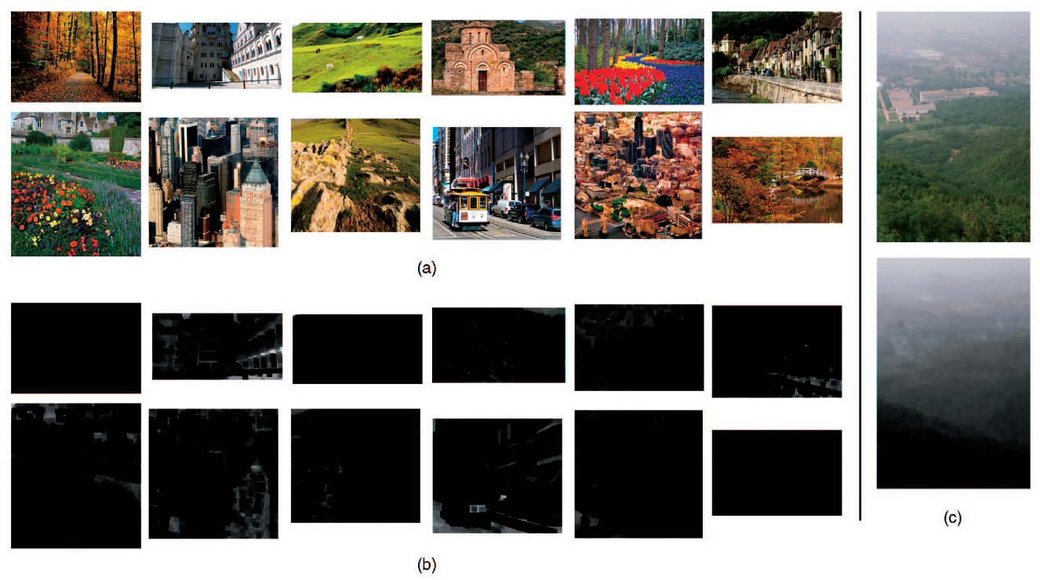

Fig. 1. (a) Outdoor haze-free images, (b) dark channels of images in (a), (c) a hazy image and its dark channel.

## Atmospheric light estimation

After getting dark channel image according to its definition, [4] mentions a method to estimate the atmospheric light *A*. The top 0.1% of the brightest pixels in the dark channel is first selected as candidates, and then the color with the highest intensity value among the candidate pixels is then used as the value for *A*. The whole process in shown in Fig.2.

If we ignore the first step of selecting candidate pixels, then the intensity values of white objects instead of haze regions in the original images may be wrongly selected as atmospheric light *A*, which would also be shown in Fig.2.

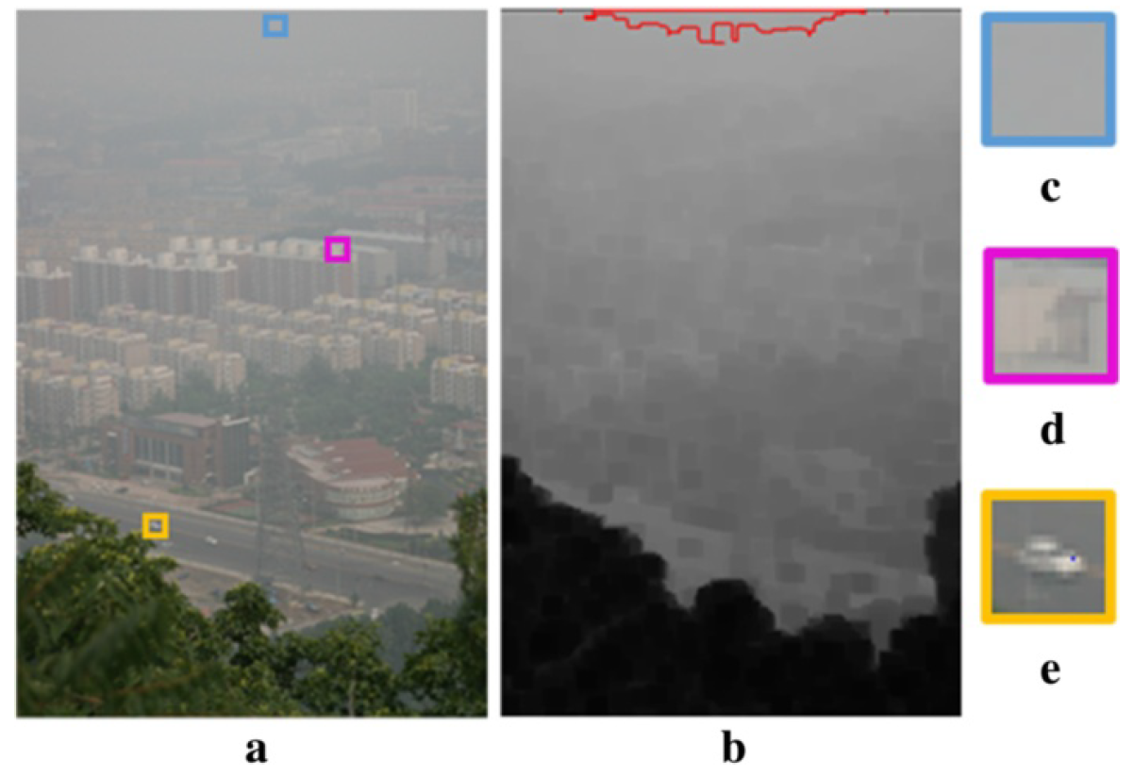

Fig. 2. Estimation of atmospheric light (a) hazy image, (b) dark channel and the region inside the red boundary lines corresponds to the most haze-opaque region, (c)patch used to determine the atmospheric light if candidate pixels have been selected, (d)(e) patch used to determine the atmospheric light if candidate pixels have not been selected.

## Transmission map estimation

Having dark channel as well as atmospheric light, the transmission map can be estimated.

The degradation model has been introduced as Equation (1). If we divide both sides of the equation by atmospheric light *A*, then we can have the minimum intensity in the local patch of each color channel:

$\min_{y∈Ω\left(x\right)}\left(\frac{I^{c}\left(x\right)}{A}\right) =\min_{y∈Ω\left(x\right)}\left(\frac{J^{c}\left(x\right)}{A}\right)t(x)+\left(1-t\left(x\right)\right)$*(6)*

Here, the transmission map within each local patch is assumed to be constant as in [4].

Then we can introduce the definition of dark channel by further imposing a 2-D minimum filter concerning RGB channel in every local patch:

$\min_{y∈Ω\left(x\right)}\left(\min_{c∈\{r,g,b\}}\frac{I^{c}\left(x\right)}{A}\right) =\min_{y∈Ω\left(x\right)}\left(\min_{c∈\{r,g,b\}}\frac{J^{c}\left(x\right)}{A}\right)t(x)+\left(1-t\left(x\right)\right)$ (7)

Because of the dark channel prior (DCP) approximation:

$J^{dark}\left(x\right)=\min_{y∈Ω\left(x\right)}\left(\min_{c∈\left\{r,g,b\right\}}J^{c}\left(y\right)\right)≈0$ (8)

the transmission map $t(x)$ can be written as:

$t\left(x\right)=1-\min_{y∈Ω\left(x\right)}\left(\min_{c∈\left\{r,g,b\right\}}\frac{J^{c}\left(x\right)}{A}\right)=1-\frac{J^{dark}\left(x\right)}{A}$ (9)

In practical use, we often introduce a parameter $ω$ ranging from 0 to 1into Equation (9) to maintain a certain degree of haze in the final result. This is because haze or fog is one of the important sources of sense of depth of field for our human eyes. If we eliminate all the haze, then the image would be too artificial.

$t\left(x\right)=1-ω\min_{y∈Ω\left(x\right)}\left(\min_{c∈\left\{r,g,b\right\}}\frac{J^{c}\left(x\right)}{A}\right)=1-ω\frac{J^{dark}\left(x\right)}{A}$ (10)

This is the basis of transmission map calculation from dark channel and atmospheric light *A*.

## Transmission map refinement

If the transmission map from section D is directly used to reconstruct the dehazed image, one of the example results are shown in Fig.3. When using un-refined transmission map, most of the haze in the original image can be removed, while the obvious block artifacts around the edges of objects are also introduced into the dehazed image. Therefore, it is of necessity to do refinement of transmission map.

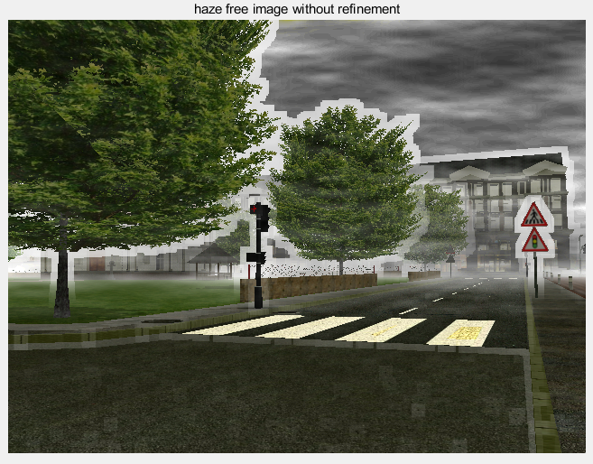

Fig. 3. Dehazed image when using un-refined transmission map.

In [4], the refinement method is called soft matting, which is a method originally used in Laplacian image matting [6].

As introduced in [4] and [6], if we denote the refined transmission map as $\tilde{t}(x)$ and the un-refined transmission map as $t(x)$. Rewriting $\tilde{t}(x)$ and $t(x)$ in their vector forms $\tilde{t}$ and $t$, then the refinement of transmission map can be done by minimizing the following cost function:

$E\left(t\right)=t^{T}Lt+λ{\left(t-\tilde{t}\right)}^{T}\left(t-\tilde{t}\right)$ (11)

Here, the matrix L is called the matting Laplacian matrix introduced in [6] as:

$\sum_{(i,j)∈w_{k}}{(δ_{ij}-\frac{1}{\left|w_{k}\right|}(1+{\left(I_{i}-μ_{k}\right)}^{T}{\left(\sum_{k}{+}U_{3}\frac{ϵ}{\left|w_{k}\right|}\right)}^{-1}(I_{j}-μ_{k})))}$ (12)

where $I_{i}$ and $I_{j}$ are the colors of the input image **I** at pixels *i* and *j*, $δ_{ij}$ is the Kronecker delta, $μ_{k}$ is the mean of the colors in window $w_{k}$, $U_{3}$ is a 3*3 identity matrix, $ϵ$ is a regularizing parameter.

The optimal $t$ can be obtained by solving the following sparse linear system function:

$\left(L+λU\right)t=λ\tilde{t}$ (13)

where U is an identity matrix of the same size as L.

However, the soft matting method, in particular the calculation of matting Laplacian matrix L, consumes a large amount of computer memory, making it impractical for images in large size.

In one of his later proposed papers [7], Doctor Kaiming He solved this problem by replacing soft matting with a new method called guided filtering.

The guided filter computes the filtering output by considering the content of a guidance image, which can be the input image itself or another different image. It can transfer the structures of the guidance image to the filtering output. As introduced in [7], the basic assumption of guided filtering is a local linear model between the guidance image and the filtering output. If *q* is denoted as a linear transform of *I*, then the guided filtering process is defined as:

$q_{i}=\overline{a_{i}}I_{i}+\overline{b_{i}}$ (14)

$a_{k}=\frac{\frac{1}{\left|w_{k}\right|}\sum_{i∈w_{k}}{I_{i}p_{i}-μ_{k}\overline{p_{k}}}}{σ_{k}^{2}+ϵ}$ (15)

$b_{k}=\overline{p_{k}}-a_{k}μ_{k}$ (16)

The guided filtering process is also illustrated in Fig. 4.

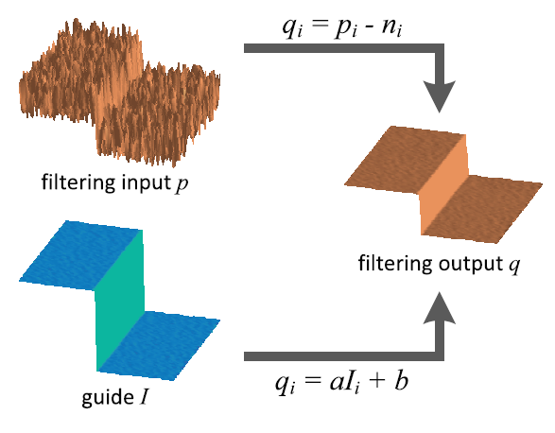

Fig. 4. Guided filtering process

In [7], the authors also give the algorithm to do guided filtering for image, as shown below.

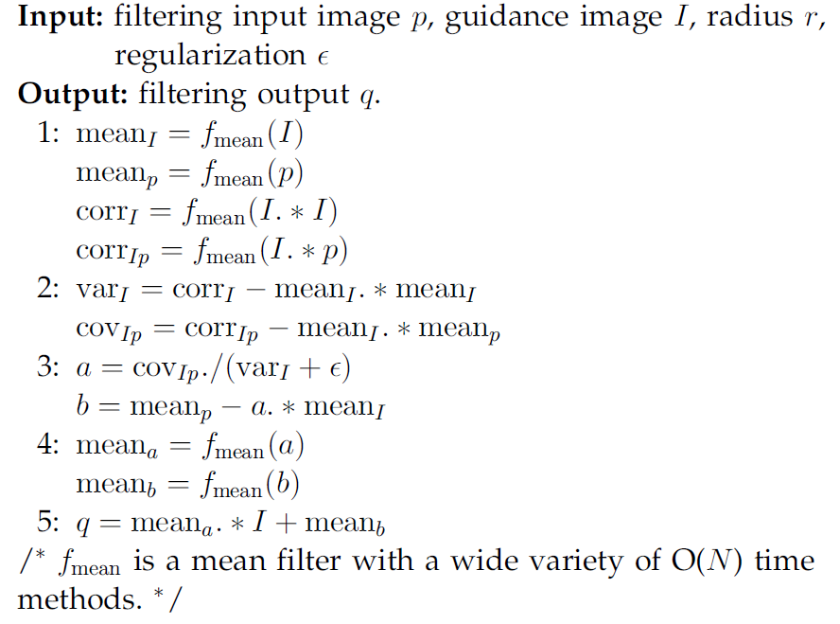

After the refinement by soft matting or guided filtering, the transmission map would be shown in Fig. 5. Compared with the unrefined one, the refined transmission map has the basic shape and the depth of field of the original image.

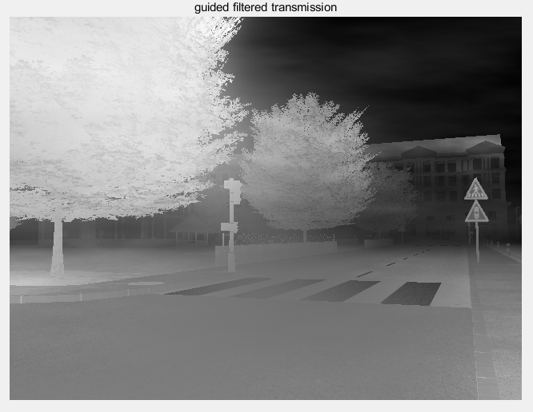

Fig. 5. Refined transmission map.

## Image reconstruction

After having atmospheric light *A* and refined transmission map *t*(x), the reconstruction of dehazed image can be done easily according to Equation (2).

The dehazing results are shown below. The dehazing algorithm successfully accomplish its task, since most of the haze is removed and a certain degree of haze is maintained intentionally from the consideration of sense of depth of field of our human eyes.

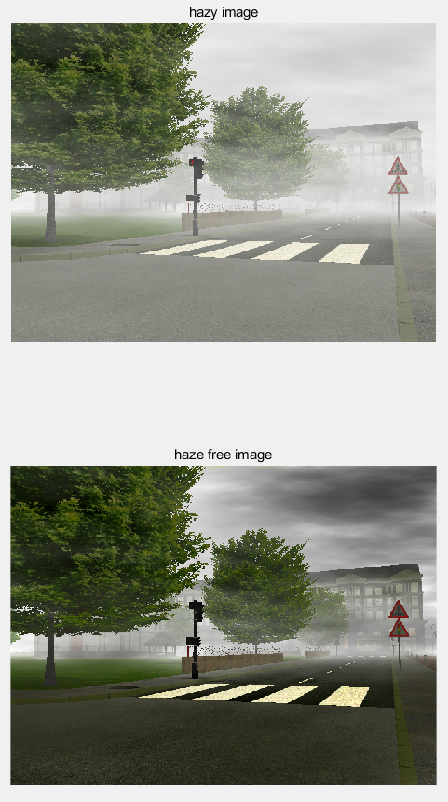

Fig. 6. Demonstration of dehazing result

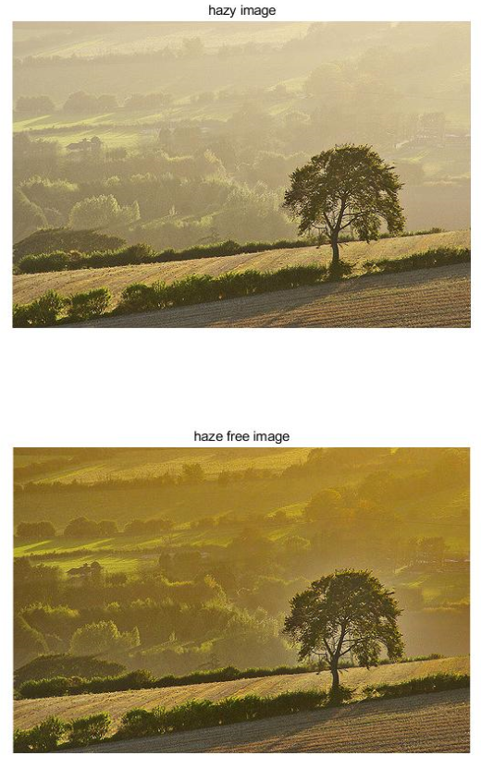

Fig. 7. Demonstration of dehazing result

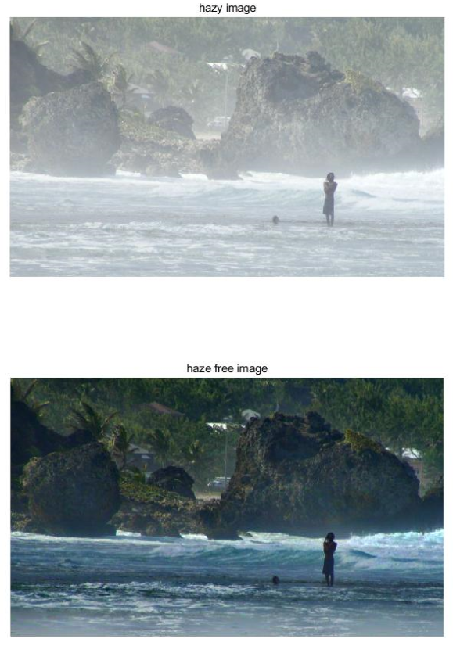

Fig. 8. Demonstration of dehazing result

# Adjustments on DCP-based Method

In previous section, the basic techniques of dark channel prior image dehazing have been introduced. In this section, several adjustments on the DCP-based method proposed by several other papers, especially in dark channel construction as well as atmospheric light estimation steps, will be demonstrated.

## Dark channel construction

As mentioned in Equation (3), the calculation of dark channel is to impose a 2-D minimum filter upon every local patch. There are mainly two methods to implement such a 2-D minimum filter. One is to use a patch-based for loop to do the 2-D minimum filter patch by patch. Another one is a fast 2-D minimum algorithm proposed by [8].

### Conventional patch-based for loop

The conventional patch-based method uses a for loop to traverse all the pixels in the input image. The patch centering around each pixel is then constructed according to the patch size. Within each patch, the minimum intensity values in RGB color channels are selected to construct the dark channel image.

In my MATLAB code, “DarkChannel.m” is the function to do the dark channel construction. Code “version 1” in this function refers to the conventional patch-based for loop method.

### Marvel van Herk’s algorithm

In [8], a fast algorithm for local minimum filtering is proposed. The algorithm is based on separability and a combination of block recursive series which are evaluated forwards and backwards. The algorithm is implemented as follows.

For 1-D input array, it is divided into sub-arrays of size *k,* with *k* being the structuring size. The recursive procedure mention in Equation (14a) is applied to every sub-array. In the resulting sub-arrays, stored in array *g*, the *i*th pixel of each group thus contains the minimum of the first *i* pixels of the same group of input array *f*. The same recursive operation is performed again on the original input array, but now backwards. The backward operation is mentioned in Equation (14b). The latter result is store in array *h*, where the (*k+1-i*)th pixel of each group contains the minimum of the last *i* pixels of the same group of the input array. To obtain the final result, as shown in Equation (14c), combine the array *g* shifted left by *k*/2 and the array *h* shifted right by *k*/2. The whole process is shown in Fig. 9.

For 2-D case, the filter can be implemented by applying operation in Equation (14) consecutively in rows and the columns.

$g_{x}=\left\{\begin{aligned}f_{x}, x=1,k+1,2k+1… \\ \min\left[g_{x-1},f_{x}\right],x=2,…,k;k+2,…,2k;2k+2,…,3k\end{aligned}\right.$ (14a)

$h_{x}=\left\{\begin{aligned}f_{x}, x=N,N-k-1,N-2k-1… \\ \min\left[h_{x+1},f_{x}\right],x=N-1,…,N-k;N-k-2,…,N-2k-1\end{aligned}\right.$ (14b)

$Result=\min\left[g_{x+\frac{k-1}{2}},h_{x-\frac{k-1}{2}}\right],x=1,…,N$ (14c)

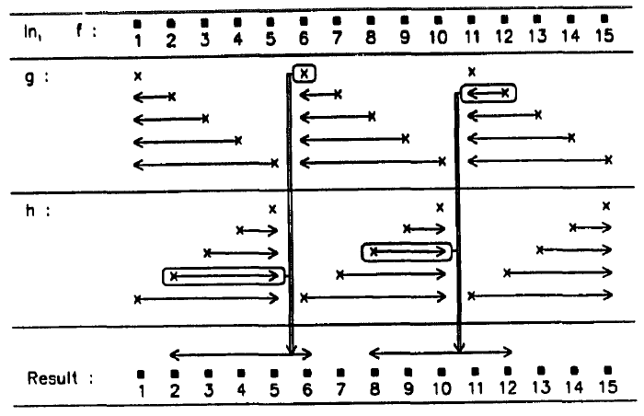

Fig. 9. Recursive method for performing local minimum filtering. The kernel size in this example is 5.

The advantage of this algorithm is that all the operations in Equation (14) only require one single comparison per array element. A local minimum operation in 2-D thus requires only 6 operations per pixel, independent of the size of the filtering kernel.

In my MATLAB code “DarkChannel.m”, code “version 2” in this function refers to this fast algorithm.

## Atmospheric light estimation

The estimation of atmospheric light contains a process of selecting candidate pixels. There are two categories of methods of selecting candidate pixels. One is called “intensity-based”, because the selection of intensity-based methods is based on the intensity of pixels in dark channel image. Another one is called “entropy-based”, because its selection is based on local entropy.

### Intensity-based methods

For intensity-based methods, pixels with a top p% dark channel values are selected as the candidates of estimating atmospheric light. Two typical values of p are 0.1 used in [4] and 0.2 used in [9]. In [10], the maximum value in dark channel image is directly used as the value of atmospheric light. This method is also intensity-based.

In my MATLAB code, “AtmosphericLight.m” is the function to do the atmospheric light estimation. Code “version 3” in this function refers to the top p% intensity-based method. Code “version 4” refers to the maximum DCP method.

The code “version 1” in “AtmosphericLight.m” refers to an early version of selecting top p% pixels. But this version uses selection sort, which is a slow sorting algorithm, consuming a lot of time for large size images.

The code “version 2” in “AtmosphericLight.m” refers to an improvement of “version 1”, by replacing selection sort with quick sort algorithm. By using a faster sorting algorithm, even for large size images, the program can be executed in a relatively short time.

#### DCP top 0.1%

#### DCP top 0.2%

#### DCP maximum

### Entropy-based method

In [11], the local entropy is used in the calculation of atmospheric light. The local entropy is defined as

$E\left(x\right)=\sum_{i=0}^{N}{(p_{x}\left(i\right)*\log_{2}{(p_{x}(i))})}$ (15)

where $p_{x}\left(i\right)$ is the probability of a pixel value *i* in the local patch centered at *x*. The low entropy value is highly likely to be low in haze-opaque regions. Therefore, in [11], pixels with the lowest entropy value is selected as candidate pixels of estimating atmospheric light.

In my MATLAB code “AtmosphericLight.m”, code “version 5” in this function refers to the entropy-based method.

# Performance Evaluation

Last section, several adjustments on the DCP-based method proposed by several other papers, especially in dark channel construction as well as atmospheric light estimation steps, are demonstrated. In this section, their performances will be evaluated qualitatively concerning program running time as well as average root mean square error (RMSE).

## FRIDA

The evaluation of a digital image processing technique based on human eyes is subjective. To make the evaluation objective, a database called Foggy Road Image Database (FRIDA) [12] can be used.

In FRIDA, it contains images without fog and it adds four different types of fog (homogeneous fog, heterogeneous fog, cloudy homogeneous fog and cloudy heterogeneous fog) onto the images without fog to form 72 hazy images. It also contains the transmission map of the images without fog. Therefore, we can use the images without fog and their transmission map as ground-truth for evaluation. Since the dehazed image is highly dependent of the refined transmission map, so I put the 72 hazy images in FRIDA into my program, get their refined transmission maps, and calculate the average root mean square error (RMSE) between the refined transmission maps in my dehazing program with the transmission maps of the images without fog in FRIDA to evaluate the performance qualitatively.

## Dark channel construction

Table I shows the time consumption comparison of dark channel construction using conventional patch-based method and Marcel van Herk’s fast algorithm in different patch sizes.

As can be seen from Table I, Marcel van Herk’s algorithm is indeed faster than the conventional patch-based method, since the time consumption of dark channel construction is around 0.2 seconds when using Marcel van Herk’s algorithm, while around 2 seconds when using conventional patch-based method. This shows the advantage of Marcel van Herk’s algorithm over conventional patch-based method.

For conventional patch-based method, as the patch size increases, the time consumption increases significantly from 1.8 seconds to 2.3 seconds. However, for Marcel van Herk’s algorithm, as the patch size increases, the time consumption only increases in a very short time scale from 0.196 seconds to 0.205 seconds. This shows another advantage of Marcel van Herk’s algorithm over conventional patch-based method – its time consumption is independent of the size of the filtering kernel.

TABLE I

Time Consumption of Dark Channel Construction

|  |  |  |
| --- | --- | --- |
| Patch size | Patch-based method (s) | Herk’s algorithm (s) |
| 3 | 1.812709 | 0.196803 |
| *7* | 1.922771 | 0.199283 |
| *11*  *15* | 2.106231  2.360858 | 0.199382  0.205353 |

Table II shows the average RMSE of dark channel construction using conventional patch-based method and Marcel van Herk’s fast algorithm in different patch sizes.

As can be seen from Table II, for both methods, as the patch size increase, the average RMSE increases, meaning that the dehazing quality decreases. This phenomenon can be explained by that as the patch size gets too large, some tiny or fine textures would be lost in some patches. Therefore, a small patch size that does not produce false textures in dark channel is favored.

TABLE II

Average RMSE of Dark Channel Construction

|  |  |  |
| --- | --- | --- |
| Patch size | Patch-based method | Herk’s algorithm |
| 3 | 0.3094 | 0.308 |
| *7* | 0.316 | 0.3148 |
| *11*  *15* | 0.3198  0.3227 | 0.3188  0.3217 |

## Atmospheric light estimation

Table III shows the time consumption comparison of atmospheric light estimation using three intensity-based methods and entropy-based method in patch size equals to 15.

As shown in Table III, under the same patch size, three intensity-based methods consume relatively same amount of time around 0.02 seconds, while the entropy-based method is more time-consuming than the intensity-based methods, spending around 0.75 seconds.

TABLE III

Time Consumption of Atmospheric Light Estimation

|  |  |  |  |
| --- | --- | --- | --- |
| DCP top 0.1% | DCP top 0.2% | DCP maximum | Entropy |
| 0.023071 | 0.022113 | 0.021875 | 0.757627 |

Table IV shows the average RMSE of atmospheric light estimation using three intensity-based methods and entropy-based method in different patch sizes.

As can be seen from Table IV, for the three intensity-based methods, the average RMSE decreases as the patch size increases, which means that a large patch size is favored if intensity-based methods are used. This is contrary to that in dark channel construction, which favors a small patch size. One solution to this contrary is to use different patch sizes for these two steps.

As for entropy method, its average RMSE does not change with the patch size. This is an advantage brought by this time-consuming method that its dehazing quality does not change even if the patch size changes. Therefore, for users who do not want to change the patch size for different steps, he or she can use entropy method to do atmospheric light estimation.

TABLE IV

Average RMSE of Atmospheric Light Estimation

|  |  |  |  |  |
| --- | --- | --- | --- | --- |
| Patch size | DCP top 0.1% | DCP top 0.2% | DCP maximum | Entropy |
| 3 | 0.3148 | 0.3148 | 0.3146 | 0.3148 |
| *7* | 0.3145 | 0.3146 | 0.3143 | 0.3148 |
| *11*  *15* | 0.3145  0.3141 | 0.3145  0.3141 | 0.3142  0.3137 | 0.3148  0.3148 |

## Transmission map estimation

As mentioned is Section II. Part E., the parameter $ω$ ranging between 0 and 1 in transmission map estimation is maintained in order to preserve a certain degree of depth of field introduced by haze. Table V demonstrates the average RMSE of transmission map estimation under different values of $ω$.

As illustrated in Table V, the average RMSE decreases as the value of $ω$ increases, which means that the haze is removed more clearly as $ω$ gets closer to 1. However, because $ω$ is introduced for maintaining a certain degree of haze, it is better not to set it to 1 and eliminate all the haze. A recommended value of $ω$ is around 0.93.

TABLE V

Average RMSE of Transmission Map Estimation

|  |  |
| --- | --- |
| ω | RMSE |
| 0.6 | 0.3427 |
| *0.7* | 0.3341 |
| *0.8*  *0.9* | 0.3256  0.3174 |

# Conclusions

In this paper, I perform a review on a fast and practical image haze removal technique based on dark channel prior (DCP). This DCP-based technique consists of five steps: dark channel construction, atmospheric light estimation, transmission map construction, transmission map refinement, and image reconstruction. This paper gives the principles behind these five steps and their implementation methods. Several other enhancements proposed by different research concerning dark channel construction and atmospheric light estimation are also introduced. The paper also evaluates the performances of different methods and parameter settings of dark channel construction, atmospheric light estimation and transmission map estimation. I believe that this review can give readers a thorough comprehension about the DCP-based dehazing methods and an instruction in selecting parameters in the algorithm.

References

1. YY Schechnner, SG Narasimhan, SK Nayar, “Polarization-based vision through haze,” *Appl. Optics* 42(3), 511-525 (2003)
2. RT Tan, “Visibility in Bad Weather from a Single Image,” in *Proceedings of IEEE Computer Society Conference on Computer Vision and Pattern Recognition* (CVPR, Anchorage, 2008), pp. 1-8
3. R Fattal, “Single Image Dehazing,” *ACM Trans. Graph*. 72(3), 72:1-72:9 (2008)
4. K He, J Sun, X Tang, “Single Image Haze Removal using Dark Channel Prior,” in *IEEE Transactions on Pattern Analysis and Machine Intelligence*, vol. 33, No. 12, 2011
5. N Hautiere, JP Tarel, J Lavenant, D Aubert, “Automatic Fog Detection and Estimation of Visibility Distance Through Use of Onboard Camera,” Mach. *Vis. Appl*. 17(1), 8-20 (2006)
6. A. Levin, D. Lischinski, and Y. Weiss, “A Closed Form Solution to Natural Image Matting,” *Proc. IEEE Conf. Computer Vision and Pattern Recognition*, vol. 1, pp. 61-68, 2006
7. K He, J Sun, X Tang, “Guided Image Filtering,” in *IEEE Transactions on Pattern Analysis and Machine Intelligence*, vol. 35, 2013
8. M. van Herk, “A Fast Algorithm for Local Minimum and Maximum Filters on Rectangular and Octagonal Kernels,” *Pattern Recognition Letters*, vol. 13, pp. 517-521, 1992
9. C Xiao, J Gan, “Fast Image Dehazing Using Guided Joint Bilateral Filter,” *Vis. Comput*. 28(6-8), 713-721 (2012)
10. Z Lin, X Wang, “Dehazing for Image and Video using Guided Filter,” *Appl. Sci.* 2(4B), 123-127 (2012)
11. S Jeong, S Lee, “The Single Image Dehazing Based on Efficient Transmission Estimation,” in *Proceedings of IEEE International Conference on Consumer Electronics* (ICCE, Las Vegas, 2013), pp. 376-377
12. J.-P. Tarel, N. Hautière, L. Caraffa, A. Cord, H. Halmaoui and D. Gruyer, "Vision Enhancement in Homogeneous and Heterogeneous Fog", in IEEE Intelligent Transportation Systems Magazine, 4:(2), p. 6-20, summer 2012.

1. Zhuowen Lin is with the Information Engineering major, Southern University of Science and Technology, Shenzhen, Guangdong, China (e-mail: 11510818@mail.sustc.edu.cn).